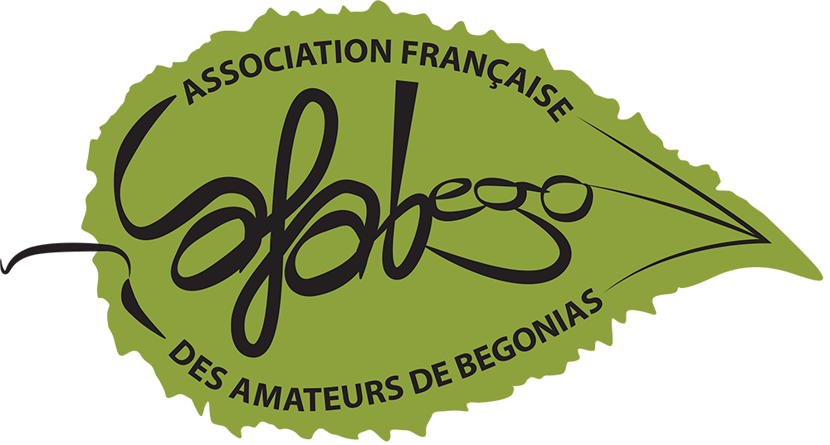
AFABEGO
Seed Department
PURCHASE ORDER
INFORMATIONS ADHÉRENT
Member Name | Member number
Address
Zip/Postal Code City | City
Country
SENDING OF THE ORDER SENDING PAYMENT
📧 Mail : alacid.kenzo@hotmail.fr Paypal: afabego@orange.fr
📬 Courrier :
Kenzo ALACID
5 route de Valence
38150 Roussillon
SEED ORDER (1 sachet per species – 20 max)
Species name | Price (€) | Species name | Price (€)
REPLACEMENT SPECIES
Species name | Price (€)

IMPORTANT INFORMATION
✔ Verification of availability.
✔ 3 € shipping costs (International tracked letter) OUTSIDE FRANCE.
✔ Wait for confirmation by email before payment.
✔ Sending after payment is received
OPTIONS
Begonia cultivation guide: 6 €

